

SYSTEM REQUIREMENTS SPECIFICATION (SRS)
MenCare Health Hub
Men’s Urological & Reproductive Health Education & Healthcare Information Platform
Version: 1.0

System Type: Web-Based Application

───

1. Introduction
1.1 Purpose of the Document
This document defines the functional and non-functional requirements for MenCare Health Hub, a web-based platform designed to provide accessible educational information about men's urological and reproductive health.
The document serves as a guide for the design, development, testing, and evaluation of the system.
The system will allow users to learn about selected health conditions, understand common symptoms and prevention measures, and locate healthcare facilities that provide relevant services.

───

1.2 Project Overview
MenCare Health Hub is an educational and healthcare information platform targeting men who want to learn more about their urological and
reproductive health.
The platform will provide structured information on conditions including:
- Benign Prostatic Hyperplasia (BPH)
- Prostatitis
- Urinary Tract Infections (UTIs)
- Urethritis
- Chlamydia
- Gonorrhea
- Genital Herpes
The platform will also provide:
- Health topic searching
- Symptom awareness
- Health facts
- Myth-versus-fact information
- Healthcare facility search
- Healthcare facility details
- Administrative content management
The system will not diagnose diseases or provide personalized medical treatment.

───

2. Purpose and Objectives
2.1 General Objective
To develop a web-based platform that improves access to understandable information about men's urological and reproductive health and helps users identify appropriate healthcare services.
2.2 Specific Objectives
The system should:
- Provide structured educational information about selected men's health conditions.
- Allow users to search for health topics.
- Help users understand common symptoms associated with selected conditions.
- Provide prevention and risk-reduction information.
- Explain when users should consider seeking professional healthcare.
- Provide a searchable healthcare facility directory.
- Allow administrators to manage educational content.
- Allow administrators to manage healthcare facilities.
- Provide a responsive interface for mobile and desktop users.
- Protect administrative functions through authentication and authorization.

───

3. System Scope
3.1 In-Scope Features
Educational Content
- Health categories
- Condition definitions
- Causes
- Symptoms
- Risk factors
- Prevention
- General diagnosis information
- Treatment overview
- When to seek medical help
- Related conditions
Health Awareness
- Symptom-awareness section
- Health facts
- Myth vs Fact
- Health warnings/disclaimers
Search
- Search health conditions
- Search symptoms/topics
- Filter conditions by category
Healthcare Directory
- Search facilities
- Filter facilities by services
- View facility information
- View location
- View contact details
- Get directions
Administration
- Administrator login
- Manage conditions
- Manage categories
- Manage health facts
- Manage healthcare facilities
Security
- Administrator authentication
- Password hashing
- Role-based access
- Input validation
- Database access control

───
4. Out-of-Scope Features
The following features will not be implemented in the MVP:
- Medical diagnosis
- AI diagnosis
- Symptom scoring
- Automated disease prediction
- Digital prescriptions
- Online doctor consultations
- Telemedicine
- Patient medical records
- Laboratory result interpretation
- Appointment booking
- Online payment
- Insurance processing
- Patient accounts
- Emergency treatment
- Direct communication with doctors
This keeps the project achievable and prevents the system from being presented as a medical diagnostic application.

───

5. Stakeholders

Stakeholder | Interest
General Users | Access health education and healthcare information
Men/Young Adults | Learn about urological and reproductive health
Healthcare Facilities | Provide information about available services
System Administrator | Manage platform content
Project Developer | Design, develop and maintain the system

───

6. User Roles
The system will have two primary user roles.
6.1 General User
The general user does not need to create an account.
- They can:
- Access the homepage
- Browse health topics
- Search health information
- Read condition information
- Explore symptoms
- View health facts
- View myth/fact content
- Search healthcare facilities
- View facility details
Access privacy and disclaimer information

───

6.2 Administrator
The administrator will require authentication.
- Administrators can:
- Log into the dashboard
- Add health conditions
- Edit health conditions
- Delete health conditions
- Add categories
- Edit categories
- Delete categories
- Add health facts
- Edit health facts
- Delete health facts
- Add healthcare facilities
- Edit healthcare facilities
Delete healthcare facilities

───

7. Functional Requirements
FR-01: Homepage
The system shall provide a homepage that introduces MenCare Health Hub.
- The homepage shall provide links to:
- Health Topics
- Symptoms & Health Check
- Healthcare Services
- Health Facts
- Myth vs Fact
- About
Privacy
The homepage shall also display selected/popular health topics.

───
8. Health Topics Requirements
FR-02: View Health Categories
The system shall allow users to view health categories.
Example:
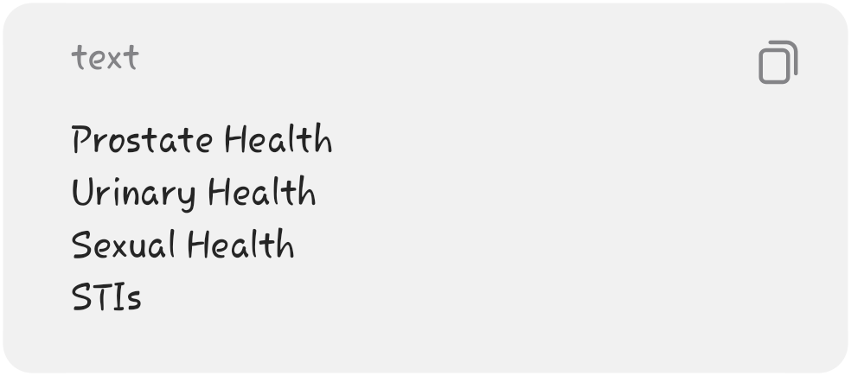

───

FR-03: View Conditions
The system shall display health conditions
belonging to each category.
For example:
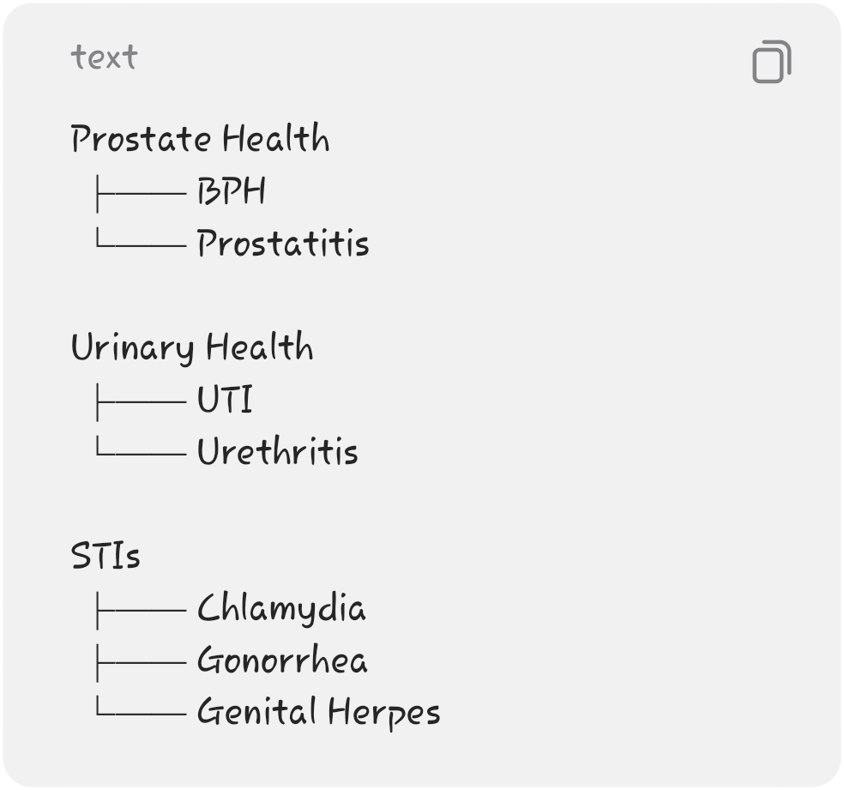

───

FR-04: View Condition Details
The system shall allow users to open an individual condition page.
- Each condition page shall contain:
- Name
- Definition
- Causes
- Symptoms
- Risk factors
- Prevention
- General diagnosis information
- Treatment overview
- When to seek medical help
Related conditions

───

9. Symptom Awareness
Requirements
FR-05: View Common Symptoms
The system shall provide a section where users can explore common symptoms.
- Examples:
- Painful urination
- Frequent urination
- Difficulty starting urination
- Weak urine stream
- Blood in urine
- Genital discomfort
Unusual discharge

───

FR-06: Symptom Information
- When a user selects a symptom, the system shall display educational information explaining that:
- The symptom may have multiple possible causes.
- The symptom alone does not establish a diagnosis.
Users should consider professional medical evaluation where appropriate.
The system may link the symptom to relevant educational topics.
Example:
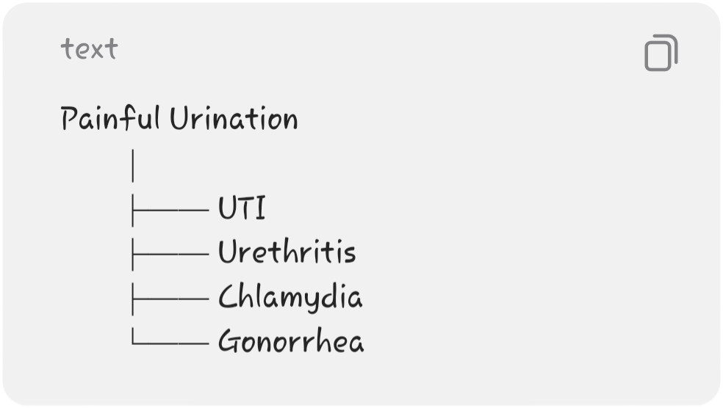

───

10. Search Requirements
FR-07: Search Health Information
The system shall provide a search feature allowing users to search health topics.
Example:
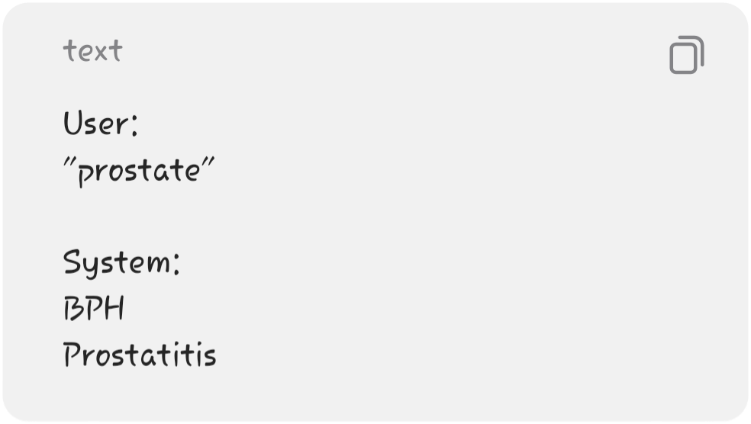
───

FR-08: Search by Keywords
- The search system should support keywords related to:
- Condition names
- Symptoms
- Health categories
Health topics
For the MVP, basic keyword-based searching will be sufficient.

───

11. Healthcare Services Requirements
FR-09: View Healthcare Facilities
The system shall provide a directory of selected healthcare facilities.
- Each facility may contain:
- Facility name
- Location
- Address
- Contact information
- Services offered
- Opening hours where available
- Latitude
Longitude

───

FR-10: Search Healthcare Facilities
Users shall be able to search facilities based on location.
Example:

The system returns relevant facilities.

───

FR-11: Filter Healthcare Facilities
Users shall be able to filter facilities by service.
Example:
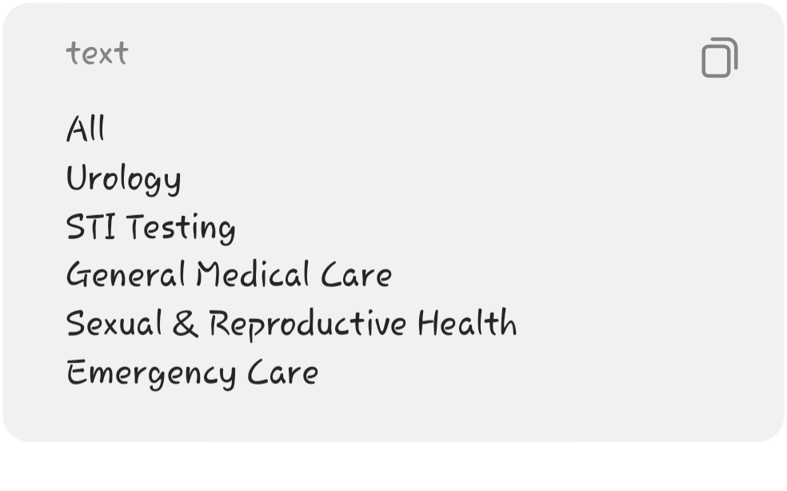
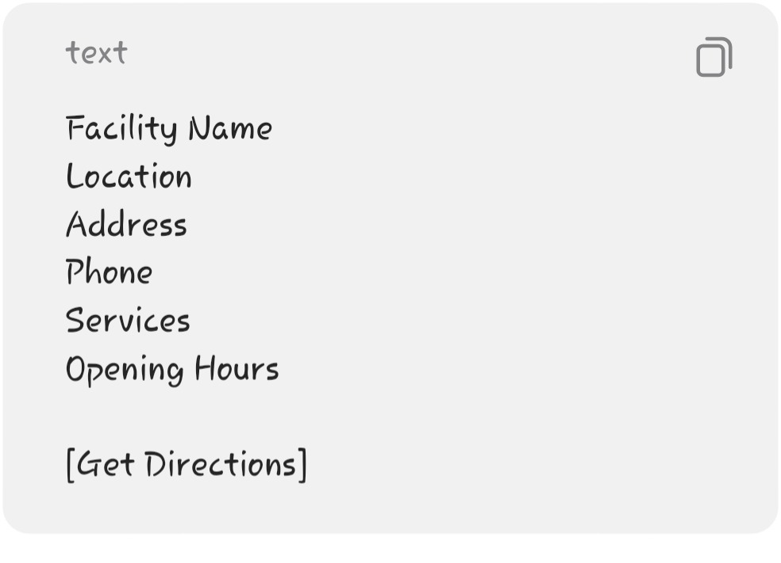

───

FR-12: Facility Details
Users shall be able to select a facility and view detailed information.
The page may provide:

The system should display a notice that facility information may change and users should confirm details directly with the facility.

───

12. Health Facts Requirements
FR-13: View Health Facts
The system shall display short educational facts related to men's health.
Example:
Some sexually transmitted infections may cause few or no noticeable symptoms.
Users shall be able to browse multiple facts.
───

13. Myth vs Fact Requirements
FR-14: View Myth and Fact Information
The system shall provide educational content addressing common misconceptions.
Example:
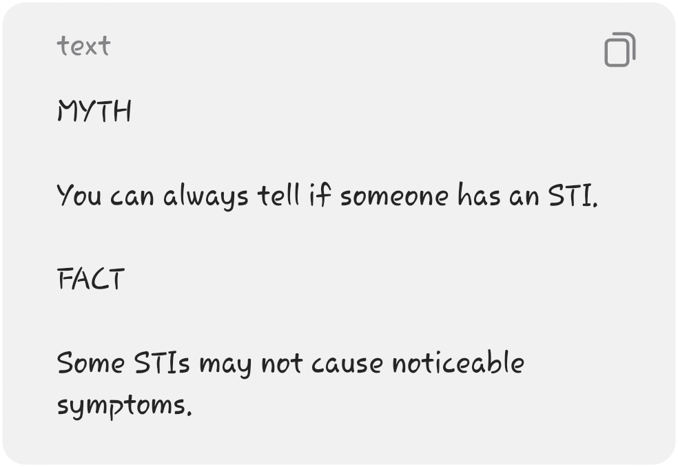
Users shall be able to navigate between different myth/fact entries.

───

- 14. About Page Requirements
- FR-15: View About Information
- The system shall provide information about:
- MenCare Health Hub
- Project purpose
- Project objectives
Target users
Educational goals
Limitations of the system

───

- 15. Privacy Requirements
- FR-16: Privacy Information
- The system shall provide a privacy page explaining:
- What information the platform collects
What information it does not require
How administrative information is protected
General data security practices
Users shall not be required to create an account to access educational content.

───

16. Disclaimer Requirements
FR-17: Medical Disclaimer
The system shall clearly communicate that:
MenCare Health Hub provides educational and healthcare information and does not provide medical diagnosis, prescriptions, or personalized medical treatment.
The disclaimer should be accessible from relevant pages.

───

17. Administrator Requirements
- FR-18: Administrator Authentication
- The system shall require administrators to log in before accessing administrative functionality.
The system shall validate:
Email/username
Password

───

FR-19: Administrator Dashboard
The system shall provide an administrative dashboard showing basic statistics such as:
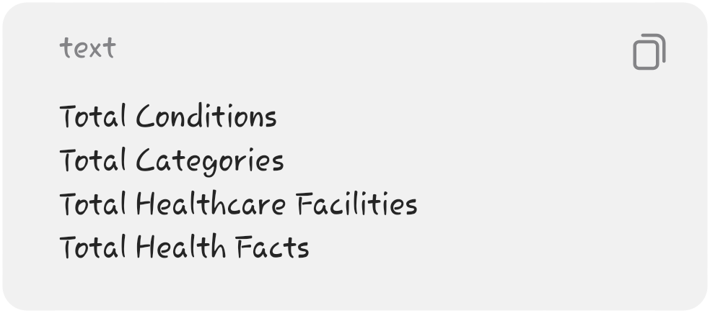

───
- 18. Content Management Requirements
- FR-20: Manage Conditions
- Administrators shall be able to:
- Create conditions
View conditions
Update conditions
Delete conditions
Each condition shall contain the required educational information.

───

- FR-21: Manage Categories
- Administrators shall be able to:
- Create categories
View categories
Edit categories
Delete categories

───

- FR-22: Manage Health Facts
- Administrators shall be able to:
- Add facts
Edit facts
Delete facts
View facts

───
- FR-23: Manage Healthcare Facilities
- Administrators shall be able to:
- Add facilities
Edit facilities
Delete facilities
View facilities

───

19. Non-Functional Requirements
NFR-01: Usability
The system shall have a simple and intuitive interface.
Users should be able to reach major sections within a small number of interactions.

───

- NFR-02: Responsiveness
- The system shall be responsive and usable on:
- Smartphones
Tablets
Laptops
Desktop computers

───

NFR-03: Performance
The system should provide reasonable response times under normal network conditions.
Health information and search results should load
without unnecessary delays.

───

- NFR-04: Security
- The system shall:
- Secure administrator authentication.
- Hash administrator passwords.
- Validate user input.
- Restrict administrative API endpoints.
Protect database operations.
Use HTTPS in production.
Implement appropriate Supabase Row-Level Security policies.

───
- NFR-05: Privacy
- The system shall minimize the collection of personal information.
- Normal users should not be required to provide:
- Full name
National ID
Phone number
Email address
to access educational content.

───

NFR-06: Maintainability
The system shall use a modular architecture so that new health conditions, categories, facts, and healthcare facilities can be added without major
changes to the application.

───

NFR-07: Scalability
The database design should allow additional health conditions and healthcare facilities to be added in the future.

───

NFR-08: Availability
The deployed system should be accessible through a web browser whenever the hosting service is available.

───

20. System Architecture Requirements
The system shall follow a three-layer architecture:
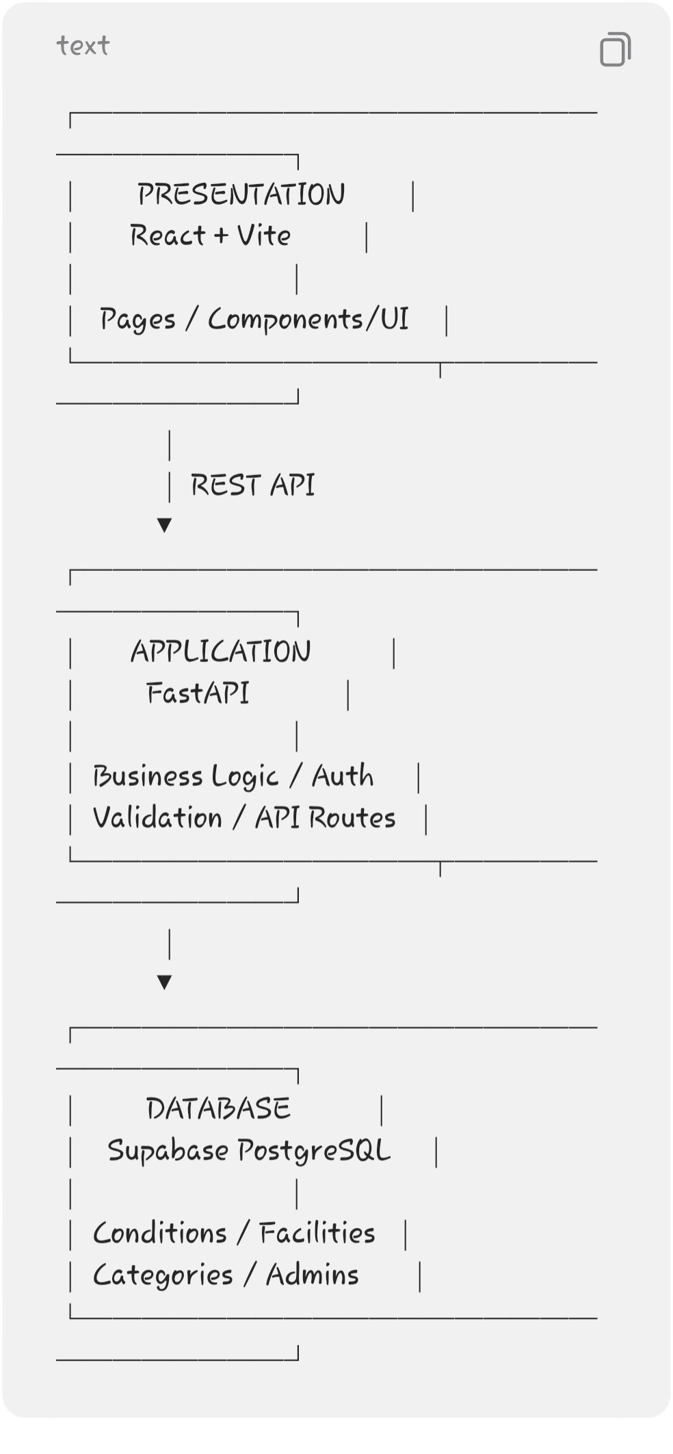

───

21. Database Requirements
The MVP database should contain approximately four main tables.
Categories
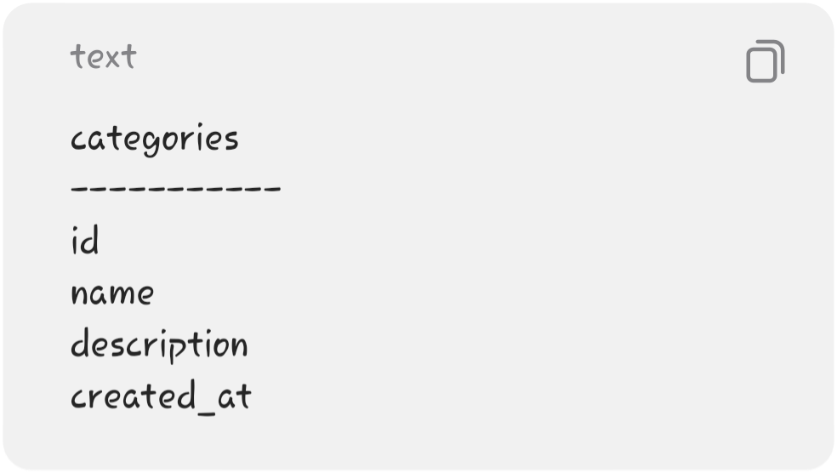
Conditions

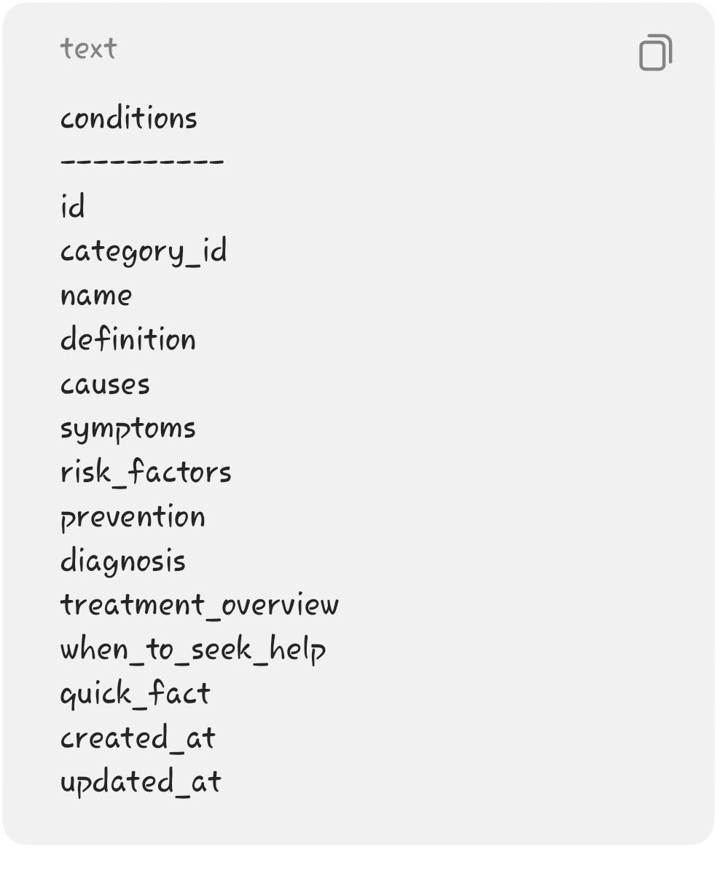
Healthcare Facilities
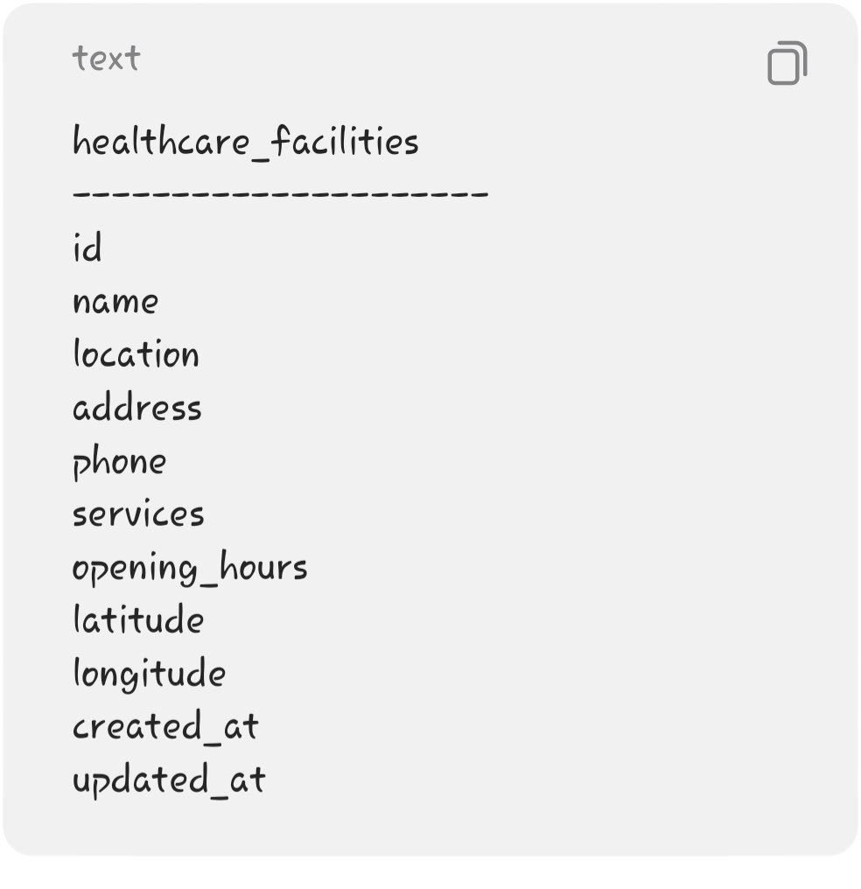
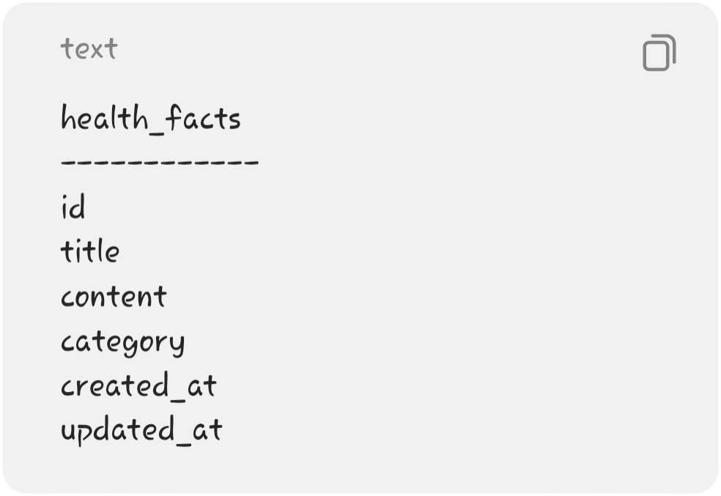
Health Facts

Admins
For the MVP, administrator authentication can be handled through Supabase Authentication rather
than creating a custom password system.

───

22. Frontend Requirements
The frontend shall contain:
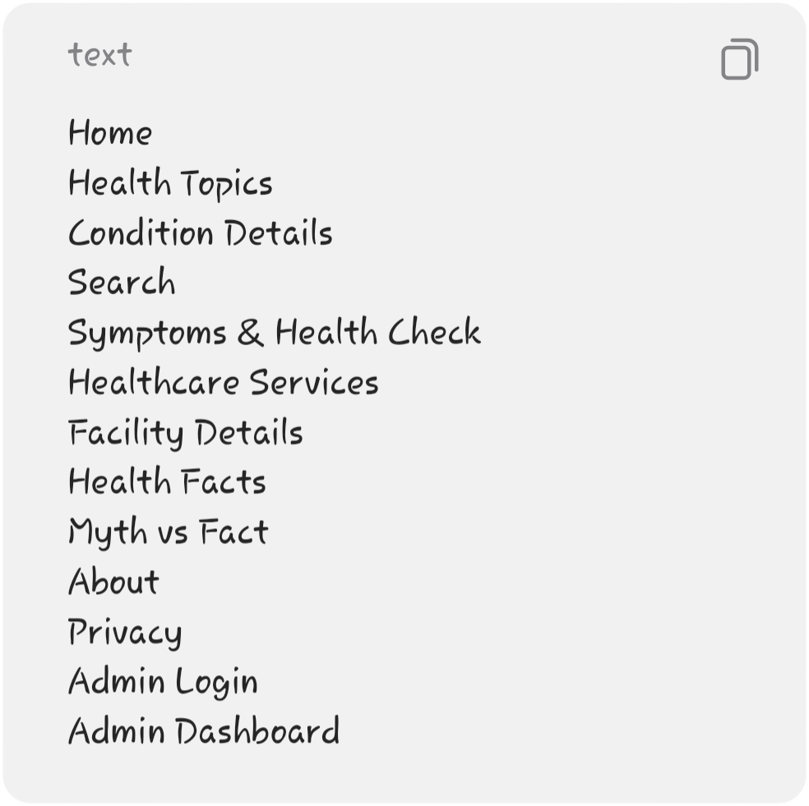
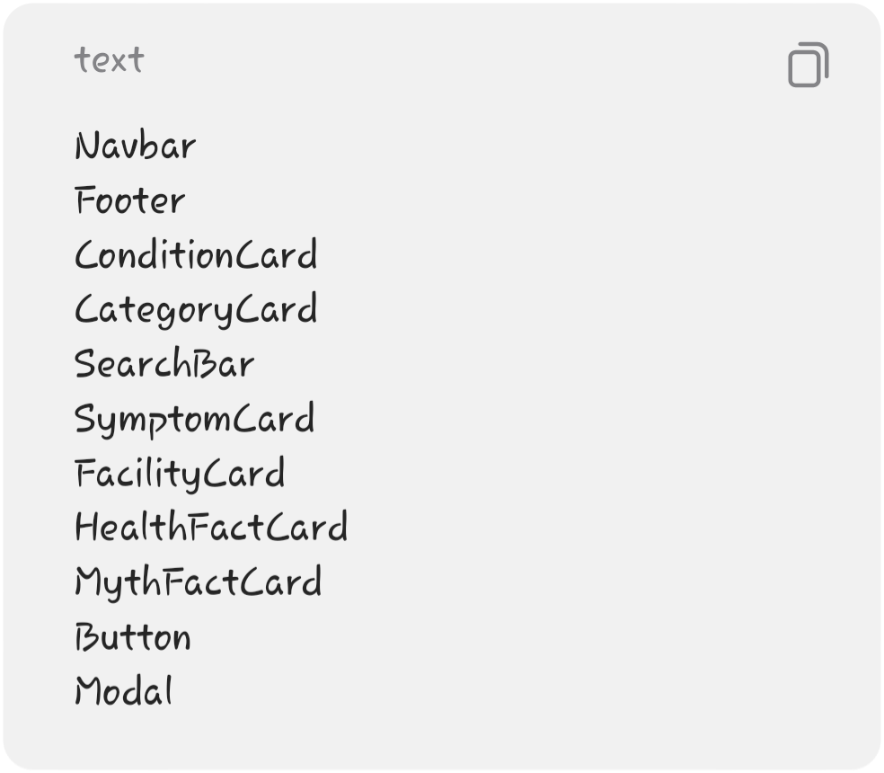
The interface should use reusable React components such as:

───

23. Backend API Requirements
The FastAPI backend should expose REST endpoints such as:
Health Topics
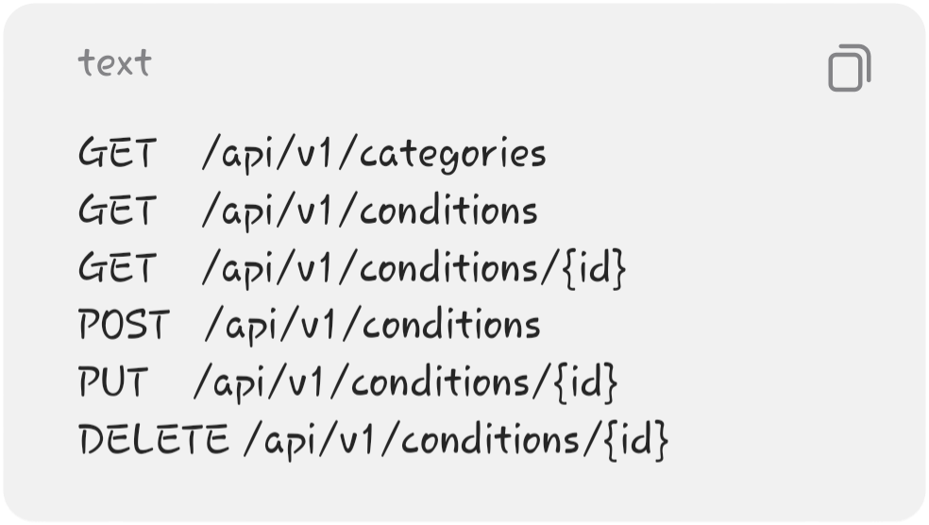
Search
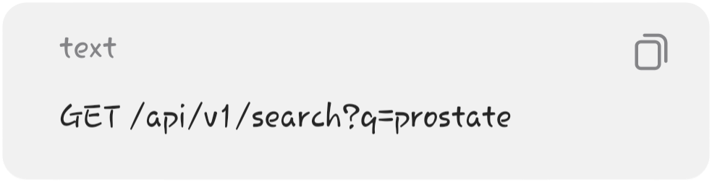
Healthcare
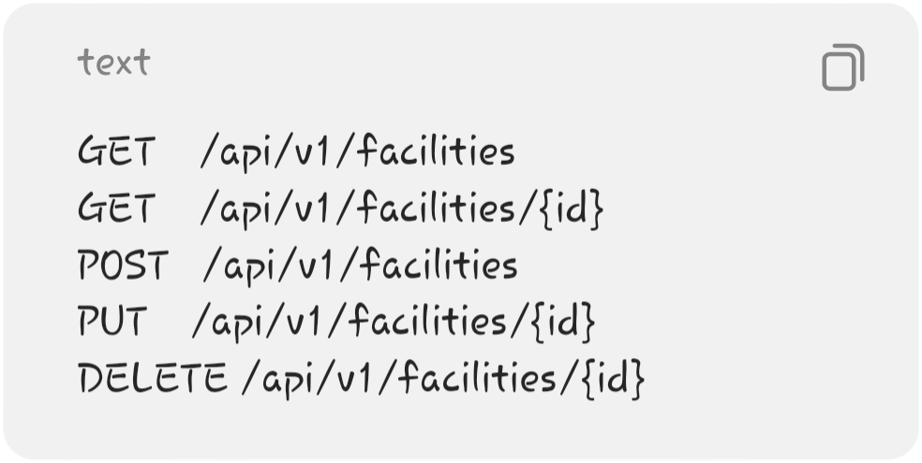
Health Facts
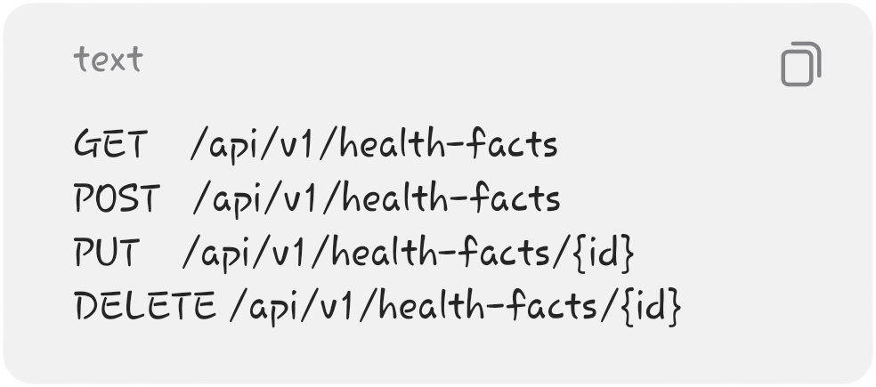
Administrative POST, PUT, and DELETE operations shall require administrator authentication.

───
- 24. External Services
- The MVP may use external services for:
- Maps
A mapping service can be used to provide directions to healthcare facilities.
Supabase
Used for:
PostgreSQL database
Authentication
Database security
Hosting-related backend services where appropriate
- No external service should be required for users to access the core educational content.
- ───

- 25. Hardware Requirements
Development Computer
- Minimum recommended:
- Dual-core processor
- 4 GB RAM
10 GB available storage
Internet connection
Modern web browser
Recommended:
Core i5/Ryzen 5 or equivalent
- 8 GB RAM or more
- SSD storage
- ───

- 26. Software Requirements
- Development
Windows/Linux/macOS
- Python
- Node.js
- npm
- Visual Studio Code or equivalent IDE
- Git
GitHub
- Frontend
- React
- Vite
- HTML
CSS
- JavaScript
- Backend
Python
- FastAPI
- Uvicorn
- Pydantic
Database
Supabase
PostgreSQL
Testing
Postman/Thunder Client
- Pytest
- Browser developer tools
- ───

- 27. System Constraints
- The project has the following constraints:
It is developed as a third-year academic project.
Development time and resources are limited.
The system will not provide medical diagnosis.
Health information must be reviewed and sourced from credible medical/health authorities before publication.
Healthcare facility information may become outdated and should therefore be verified periodically.
- Internet access is required to access the deployed web application.
- The MVP will initially cover only a limited number of health conditions.

- ───

- 28. Assumptions
The project assumes that:
Users have access to a web-enabled device.
Users have basic internet access.
Users understand that the platform is educational.
Healthcare facility information supplied to the system is reasonably accurate at the time of entry.
Administrators are responsible for maintaining educational content.
- Users requiring diagnosis or treatment will seek qualified healthcare professionals.
- ───

- 29. MVP Priority
- To prevent the project from becoming too large, the features should be prioritized as follows:
- 🔴 Must Have
- Home page
- Health Topics
- Condition Details
- Search
- Symptoms & Health Check
Healthcare Services
- Facility Details
- Admin Login
- Admin CRUD
- Database
- Responsive design
Medical disclaimer
- 🟡 Should Have
- Health Facts
- Myth vs Fact
- Category filtering
- Map/directions
Basic dashboard statistics
- 🟢 Could Have
- Dark mode
- Bookmarks/favorites
- Advanced search
- Educational articles
- Multilingual content
- ❌ Not in MVP
- AI chatbot
AI diagnosis
Symptom scoring
Patient accounts
Telemedicine
Appointment booking
Online payments
Electronic medical records

───

Core MVP philosophy:
MenCare Health Hub does not diagnose. It educates, creates health awareness, and connects users with relevant healthcare information.

